**CAP 447: DATA WAREHOUSING AND DATA MINING - LABORATORY**

**PRACTICAL-C.A-4**

**ST_NAME: - EKHLAKH AHMAD**

**REG NO.: - 12209166**

**ROLL NO.: - RD2215B67**

**SECTION: - D2215**

**GROUP: - B**

**Q. To Implement K-Mean Clustering on Golf Data Sheet**

**process: -**

* Open Rapid Miner software.
* Select data “Golf”.
* Draw data in blank area.
* Select attribute “Select Attribute”.
* Draw the blank area.
* 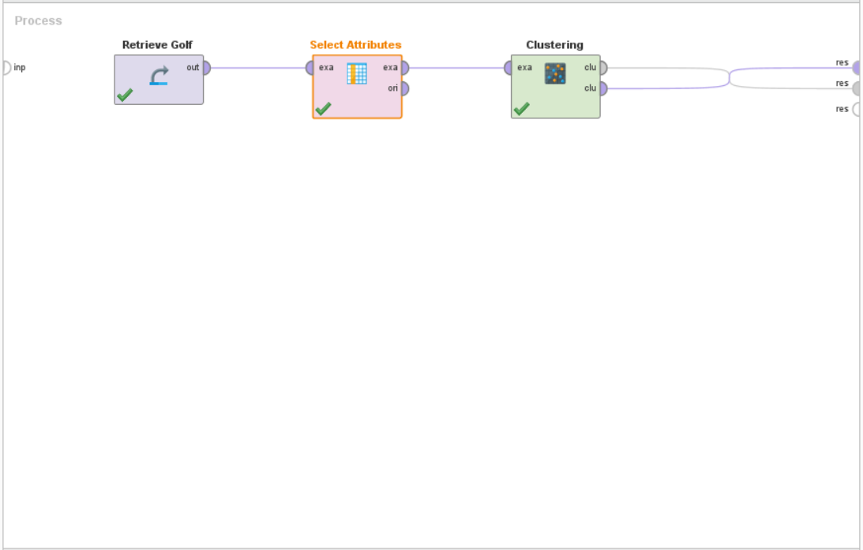Connect both to self and connect to result.
* After connect to result port.
* Select attribute form select column as you need.
* Again, click on K-mean clustering and select attribute as you need.
* 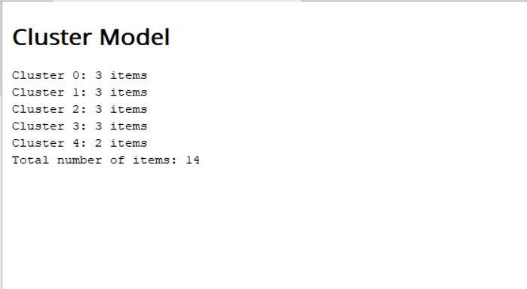Click on play button.